Tutorial for Texture Maker 2.5 or above.

Note:- Texture Maker is a texture creation tool by Tobias Reichert.
For further product information please visit the official
site at http://www.texturemaker.com

All textures produced with Texture Maker.

Prerequisites: Texture Maker 2.5 or above.
Knowledge of the programs interface.

Steps: 18.
Difficulty: Intermediate.

Adding Detail With A Gradient.

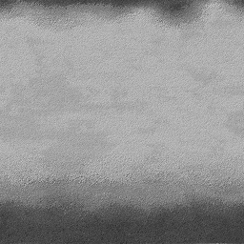

Step 1.

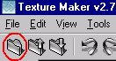
Lets begin by creating a new texture by clicking on the new texture button on the TMAK toolbar(as shown in the image below).

The create texture dialogue box appears:

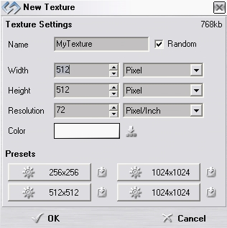
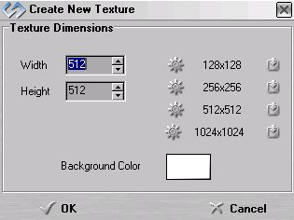

Note that there are two different images for the texture creation dialogue box as shown above. The lefthand image is for versions prior to 2.7 while the righthand image is for version 2.7 and above.

Set the "Background Color" to "White" and the "Texture Dimensions" to "Width & Height = 512".

In all these Texture Maker tutorials the creation size is 512x512. This is because it is easier to work at the larger resolutions. You can always resize the texture once you have completed it. If your screen size limits you from working at this size simply use the next one down, all these tutorials can just as easily be followed with a size of 256x256.

Once you are happy with the settings simply click the "OK" button to proceed.

Step 2.
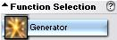
Under "Function Selection" expand the
"Generator" group and select "stone":

Step 3.
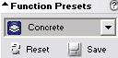
Select “Concrete” under “Function Preset”:

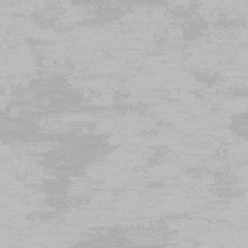
Apply to the new texture you just created, for a result similar to one shown below:

Step 4.

Create another new texture as described in Step 1.

Step 5.

Under “Function Selection” expand the “Basic”
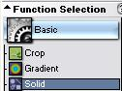
Group and select “Solid”:

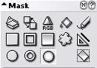

Set the mask to “Ellipse Gradient”.

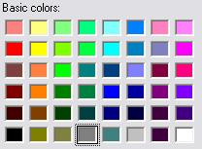
Step 6.

Set the foreground colour to
a medium gray:

Step 7.

Draw the circles so they overlap the top and the bottom of the texture, as in this example:
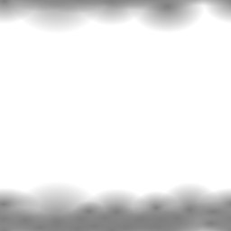

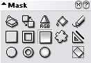
Step 8.

Set the “Mask” to “Rectangle Gradient”:

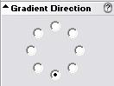

And the direction to 6 O’Clock.

Step 9.

Draw the “Rectangle Gradient” so that it starts at the
Bottom of the texture and cover all of the “Circle Gradients” previously drawn. See example below:



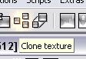
Step 10.

Clone the “Concrete” texture:

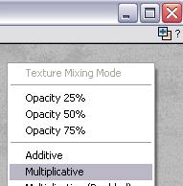
Step 11.

Drag “Quick Texture Mixer” from
the cloned texture to itself
and select “Multiplicative” from
the pop-up menu:

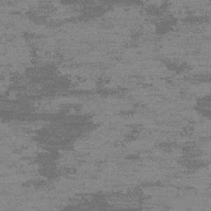

The result will resemble the example to the left. Which I’ll refer to as “Dark Concrete” for the duration of this tutorial.

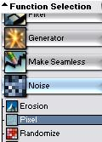

Step 12.

Under ”Function Selection” expand the
“Noise” group and select “Pixel”:

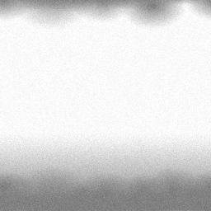

Apply this to the “Gradient”
texture for a result like the
one shown on the left.

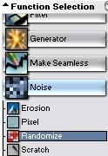
Step 13.

Select “Randomise” from the “Noise”
group under “Function Selection”:

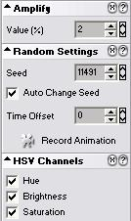

←Set the options as shown in this image.

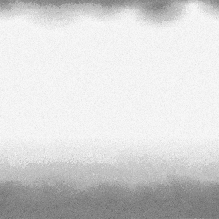

Apply the function to the
“Gradient” texture →

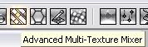
Step 14.

Start the “Advanced Texture Mixer”:

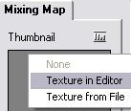
Step 15.

Click on the mixing map and select
“Texture In Editor” from the pop-up menu:

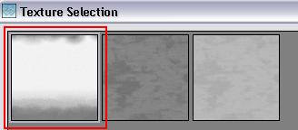

Select the “Gradient” texture.

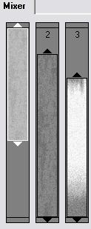

Add the “Light Concrete” texture to “Mixer”
position 1.

The “Dark Concrete” texture to position 2.

The “Gradient” texture to position 3.

Then slide and expand the positions to fit
something like the example below:

Set the rest of the options as shown below:

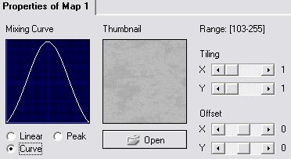

Step 16.
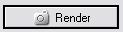
Click the “Render” button:

The result should look similar to the one below:
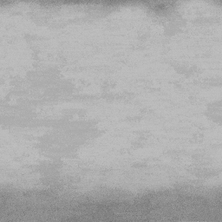

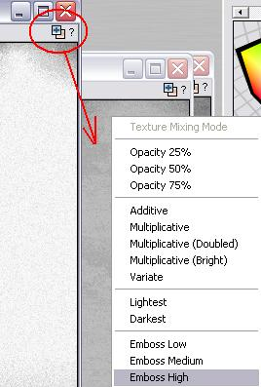
Step 17.

Drag “Quick Texture Mixer” from the
“Gradient” texture to “Advmixer”
texture, and select “Emboss High”
from the pop-up menu:

Step 17 - Continued.

Here is a similar result:
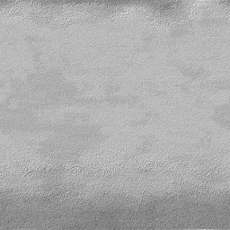

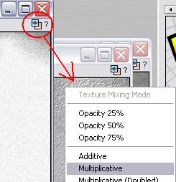
Step 18.

Drag “Quick Texture Mixer” from the
“Gradient” texture to “Advmixer”
texture, and select “Multiplicative”
from the pop-up menu:

← Here is the finished product.

On the last page are more examples created in exactly the same way.

Other Examples.

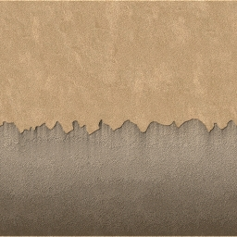

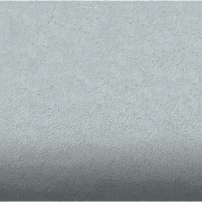

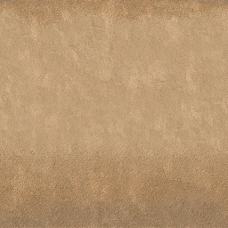

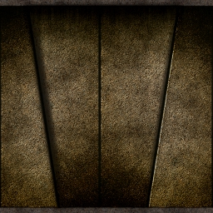

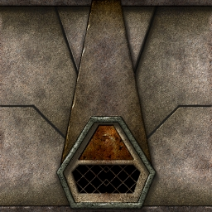

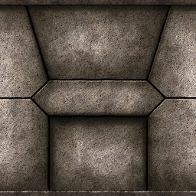

That concludes this tutorial.
_______________________________________________________________________

